# **Best location to set up Japanese Restaurant in Singapore**

Lukas Tham

December 30th, 2019

## **Introduction**

Although Singapore is one of the smallest countries in the world, Singapore is an economic giant. Having the best economy in Southeast Asia for almost a century, it is also a multiracial country which contains Chinese, Malay, Indian and Eurasian cultures and religions. Furthermore, Singapore contains many neighbourhoods in the East, West, Southern and Northern Region. Since Singapore is a multiracial country, it contains many different cultures, especially in the culinary industry. There are many different restaurants in Singapore from different cultures such as Japanese, Chinese, Malay, Indian, Western, and the list expands further. To open a restaurant in Singapore can be challenging as there are already so many restaurants with different cultures in Singapore and to open a similar restaurant selling food that is similar to what others are selling can be difficult as we have to compete with those highly established restaurants.

## **Problem**

Data that might help to identify the best location to set up a restaurant, in particular a Japanese restaurant in Singapore might help stakeholders, to maximise revenue with the gaps that can be identified. Therefore, this project helps to identify how can we find the best possible location to help stakeholders set up a Japanese restaurant in Singapore.

## **1.3 Interest**

Stakeholders such as restaurant owners, or young entrepreneurs in Singapore hopeful to open a Japanese restaurant in Singapore would be interested in this data as it will help them to obtain as many customers as possible so as to gain more revenue and become more successful as a result.

## **2.1 Data Collection, Data Pre-processing**

Using the FourSquared API, I obtained the latitude and longitude data of all Japanese restaurant in the area of Clementi. Since the data collected has already been pre-processed and cleaned, and it is parsed through using JSON, I am able to pre-processed the data easily and convert it into a dataframe.

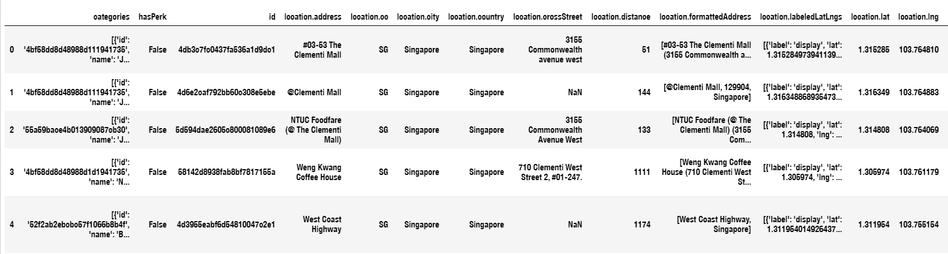

However, these data collected require cleaning, as some of the headers are difficult to understand. Furthermore, some of the data collected are not needed for the purpose of the project. Therefore, I had to change the header name to help create an easier understanding of the dataset.

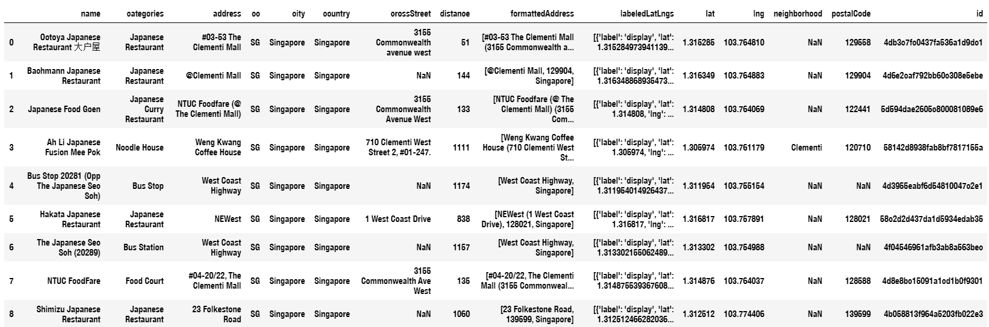

## **3. Methodology**

Using the Foursquared API, I also made use of other libraries such as geocoders, json_normalize, folium to help with this project. Before I began the project, I decided to search a radius of 1000 to determine how many Japanese restaurants are available from the centre of Clementi, which is located at the train station of Clementi. As most of the people commute by train, it will normally generate more customers around that particular area. Afterwhich, I used the folium library to plot the geospatial map to understand where are the gaps which Japanese restaurants are not available in that particular area.

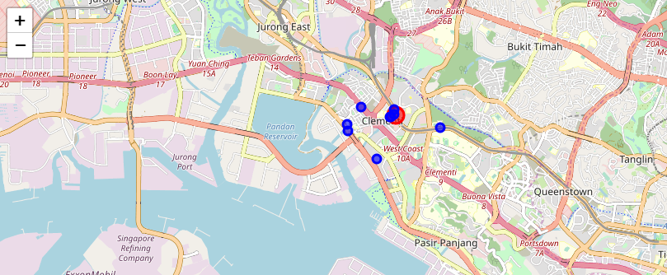

From the image above, we can identify that the North-East Region from the centre lacks Japanese Restaurants. We also can identify that that area, also known as the Sunset Way area, has lots of housing estates, and most of these people living there are middle to high-income earners. Therefore, they are able to afford to dine at restaurants. Furthermore, to confirm that particular study that there is a lack of Japanese restaurants, I performed the same task and identify the lack of Japanese Restaurants in that area from the Sunset Way centre area.

Using the same methodology and 250 radius from the centre, I want to identify any possible Japanese Restaurant in that area.

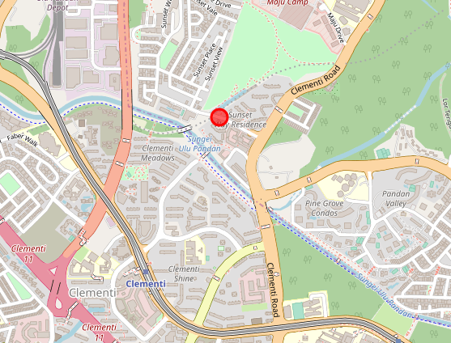

As analysed above, there are no Japanese restaurants from the centre of Sunset Way Residence.

## **4. Conclusion**

In this study, I analysed the possible locations to set up a Japanese restaurant using the Foursquared API data. I identified the Longitude, Latitude, and the area which may lack the Japanese restaurant. This study is very useful for stakeholders to set up a restaurant they would particularly be interested in setting up should they wish to find a suitable location in the Clementi region.